SRJC COUNSELING GRADUATE INTERNSHIP PROGRAM
Updated Fall 2021

Internship Program Mission Statement
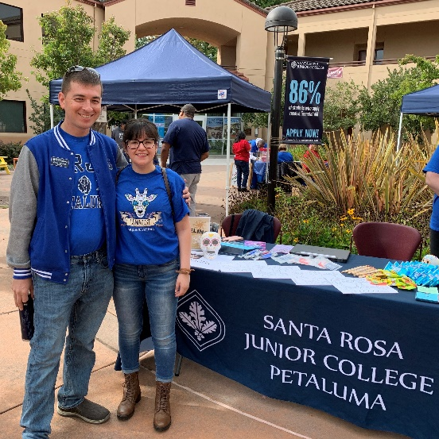
The SRJC Counseling Internship fosters the development of aspiring counseling professionals who strive to serve community college students of present and future generations. Counseling Interns are supported in the foundational tenets of the community college counseling profession including academic, career, and personal counseling as well as academic instruction. The internship provides opportunities to practice counseling methodologies with students across a spectrum of racial, ethnic, gender, sexual orientation, language, age, ability, religious, and socioeconomic diversity. Successful completion of the SRJC Counseling Internship promotes readiness to pursue community college counseling faculty opportunities.

SRJC Internship Program Overview
The internship at the SRJC Counseling Department is a two-semester program designed to provide the information and experiences necessary to become a community college counselor. The training will include exposure to the full range of services provided by SRJC and an understanding of how Student Services and Counseling contribute to the mission of the College.

The internship experience is designed to support the academic pursuits of currently enrolled graduate students whose primary objective is to gain community college counseling experience and training. The number of accepted interns will vary according to the availability of counseling faculty who are willing and able to provide supervision and training. While completion of the internship does not guarantee hiring into the SRJC adjunct counseling pool, interns that successfully complete the program will be well prepared for the community college faculty application and selection process that is commonly followed statewide.

Prospective Intern Qualifications
- Minimum Qualifications
  - Current enrollment in a master’s degree program focused on one of the following areas: counseling, rehabilitation counseling, clinical psychology, counseling psychology, guidance counseling, educational counseling, social work, career development, marriage and family therapy or marriage, family and child counseling, OR the equivalent.
    - All coursework must be from an accredited college or university, and include coursework demonstrating sensitivity to and understanding of diverse academic, socioeconomic, cultural, religious, sexual orientation, gender identity, ability, and ethnic backgrounds.
- Desirable Qualifications
  - Completion of at least one year of graduate program.
  - Completion of a graduate course in multicultural counseling or related subject.
  - Experience in counseling, education, leadership, or closely related fields.
  - Experience providing programs and/or services for diverse populations.
- Intern Expectations
  - Ability to commit to a mutually agreeable weekly schedule that fulfills hour requirements established by graduate program. It is generally expected that this consistent schedule will be within the range of 10-20 hours per week.
  - Commitment to the full two semester internship program.
  - Inquisitiveness regarding the role of the community college counselor.
  - Desire to learn the information critical to the delivery of effective and accurate counseling services to students.
  - Interest in learning and participating in each of the three counseling components (academic, career, and personal concerns) as they relate to student academic success.

Intern Program Promotion/Publicity (Pre-Internship: January – April)
- Information regarding the SRJC Counseling Department Internship program will be available through the SRJC Counseling website. This will include upcoming internship opportunities, program application, submission process/deadlines, and program contact information. This information will be updated annually at minimum.
- Program information will also be available in limited print format for distribution at Internship Fairs, Counseling Graduate Programs, or to prospective interns that may visit an SRJC location in-person.

Application and Deadlines (Pre-Internship: February – April)
- All prospective interns must complete a Counseling Internship Application.
- With the program application, all interns must provide a cover letter and résumé/curriculum vitae.
- Applications for the next academic year will be reviewed on a rolling basis at the end of each month, February - April.
  - Consideration of applications submitted after April will be dependent upon Counseling Mentor availability.

Interview/Selection Process (Pre-Internship: March – May)
- All counselors interested in acting as a Counseling Mentor will have opportunity to be part of the Counseling Intern Selection Committee.
- Once interviewed, counselors will review the selection of interns, including available areas for assignment, special projects, and any other considerations of ideal fit for intern and department.
  - The Required Qualifications, Desired Qualifications, and Intern Expectations listed above may be used to as screening criteria for potential interns.
- A second interview is arranged only if deemed necessary by the selection committee.

Onboarding Process (Pre-Internship: May – August)
- Interns will be notified of selection by telephone or email. Counseling Interns will also be provided with important dates, training information, intern contract, confidentiality agreement, parking permit information, and contact information of their designated mentor counselor.
- Selected Counseling Interns will be required to complete provide proof of a completed tuberculosis (TB) test and background check. Interns will be responsible for all fees associated with the TB test and Livescan background check.
- The Counseling Intern will coordinate with their Mentor Counselor to review placement requirements and expectations, including determination of weekly schedule commitment for the upcoming semester.
- Specialized placements may be reviewed by the Department Chair and/or Dean regarding terms of the placement including intern qualifications, nature of student contact, length of placement, and desired outcomes.

Internship Overview (Internship: August – May)

Counselor Observer – First Eight Weeks (August – October)

- Weekly meeting with intern supervisor
  - Supervision will include review of sample Student Education Plans as well as discussion of ethical issues regarding counseling and student rights.

- Observation of: counselor appointments
counselor drop-in
counseling classes
high school liaison activities
student services and related campus visitations
college organization and governance

- Interns will observe a minimum of five different counselors during first eight weeks.

- Review of counselor information online binder, articulation, matriculation, admissions and records, registration information

- Practice making education plans for hypothetical students.

- Other activities by arrangement (career testing, etc.)

- Intern Evaluation

Counselor Assistant – Second Eight Weeks (October – December)

- Weekly meeting with intern supervisor

- Supervised contact with students (appointments and drop-in).
  - Interns will be observed as a counselor assistant by a minimum of three different counselors.

- Assigned time in specialized Student Services areas (Disability Resource Center, Transfer Center, EOPS, CalWORKs, Financial Aid, etc.)

- Counseling Class visitations

- Shared Governance observations

- Other activities by arrangement

- Intern Evaluation

Counselor - Second semester (January – May)

- Weekly meeting with intern supervisor

- Counselor appointments, appropriate supervision as needed

- Counselor drop-in, appropriate supervision as needed

- Co-lead Counseling 270 and/or orientations

- Opportunity for in-depth exposure to particular counseling program areas

- Other activities, including broader faculty participation, by arrangement

- Mid-Semester Intern Evaluation

- Counseling Career Search Preparation
  - Finding Counseling Faculty Opportunities Online (cccapply.org, district websites)
  - Application Completion Assistance
  - Diversity Statement Support
  - Résumé and Cover Letter Development
  - Interview Question Practice (ideally with at least two counselors)
  - Interview Presentation Development and Rehearsal
  - Possible Writing Sample/Ed Plan Development Interview Practice

- Final Evaluation and Exit Survey

