Oct 14, 2021

Hi Everyone,

It’s Health Science Program application season which means I will probably send out more emails about Dental Hygiene than you ever wanted, but so many things come up during this time that I want to make sure to share the info in writing if I have it.

Remember this application cycle is the first in which the student must complete a Diversity Requirement/Ethnic Studies course.  Soc 30 is ideal, but they can pair Soc 1 with any of the listed courses on the major in that area (screen shot below)….. we are getting a lot of students who are caught between the old major and the new one.  So I wanted to share some course sub information that has come up and worked for a few of us.

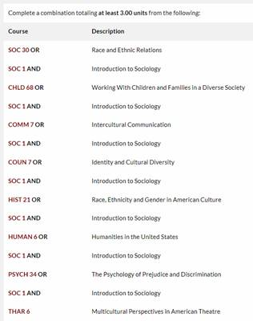

If a student is looking to pair classes to meet the Ethnic Studies/Diversity requirement, remember in addition to Soc 1 and 30 the previous major had Soc 10 and Soc 2.  You can have the student do a sub using Soc 10 or Soc 2 in place of Soc 1 and pair it with any of the listed classes above, or anything from GE OPT A Area G.  It’s important that the student list in the comments of the course sub that they worked with you on this sub.  When Cindy sees the name of a Counselor listed, it makes her job of approving these easier.

cid:image004.png@01D7C0E3.E277A500

So here’s another one that came up yesterday.  A student worked with one of us over a year ago and was ready to apply to the program last fall.  The Counselor obviously didn’t tell him about the major changing I assume because they thought it wouldn’t impact him since he was applying then.  He didn’t get in that year so he is applying again but this round, he was thought to be ineligible since he doesn’t have a diversity requirement complete.  I took a look at his transcripts and noticed he had Soc 1 and Anthro 2 from Yuba College.  Anthro 2 does not meet our American Cultures/Ethnic Studies requirement at SRJC, but I spoke with Cindy the Program Director and she said she has more leniency with this and it does meet her requirements.  She is willing to accept even our Anthro 2 as a course sub paired with Soc 1 (or Soc 2 or Soc 10).

I had someone ask me where in writing they could find DH course sub information for some of these classes, and my response was that usually you can’t and you just have to be creative and think outside the box with this stuff.  So if anyone comes across a course pairing you think might work that we haven’t already discussed, try it or send it to me and I can talk to Cindy about it.

Lastly, as a reminder, Psych 9 does count as the “or higher level math” for the math DH pre-req.  According to Evaluations, that does NOT need a course sub.